Transaction Approval Rules

Exercise 1: Investigation

1. Disable all Initial Reserve Rules that pertain to auto claims before creating these reserve lines. Reload changed classes.

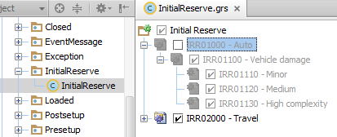

1. Follow these instructions to create transactions that require approval.

a. Log on to ClaimCenter as Betty Baker. She is an auto adjuster. Using the quick claim wizard, create a new personal auto claim using the policy issued to Larry Gamney. Use "Rollover" as the loss cause.

b. Create an exposure using "Medical Payments” for the insured. Make up a corresponding injury for Larry Gamney.

c. Create two reserve lines simultaneously for the exposure:

* Claim Cost - Medical - $10,000
* Claim Cost – Unspecified Cost Type/Category - $10,000

(When you click Save on the Set Reserve screen, you may get a validation warning. You can ignore it.)

1. The transactions require approval. How would an end user know this?

1. What is the reason the transactions require approval? How would an end user be able to determine this?
2. Do the two transactions belong to the same transaction set? Where in the user interface can you go to verify this?
3. Who is responsible for providing approval? What is the ruleset and rule name that assigned this approval request to this individual?
4. Log onto ClaimCenter as the person who is supposed to approve the transactions. Is it possible to approve one reserve and reject the other? What is it about the user interface that makes this possible or impossible?
5. Re-enable all Auto Initial Reserve rules (IRR01000 – Auto).

**Exercise 2: Configuration**

Configure ClaimCenter to meet the following customer requirement from Acme Insurance.

**Requirement 1: Approval for Reserves on claims where fault rating is unknown**

In some cases, the fault rating is undetermined at the time of claim creation. The Fault Rating field is set to “Fault unknown” and the claim is adjusted as usual. Eventually a fault rating is determined and the field is updated.

Acme's business policies let adjusters create reserves on claims where the fault is unknown, but the reserve requires approval by the supervisor of the claim’s assigned group.

1. Create the rule(s) needed to enforce these behaviors:

* Any reserve transaction on a claim with an unknown fault rating requires approval by the claim’s assigned group supervisor. If approved by the supervisor of the group to which this claim was assigned, do not require further approval; in other words, allow supervisors to approve the transaction without exception.

1. The ClaimCenter implementation team has provided additional notes:

* The reason for the approval should be "Reserve on claim with unknown fault rating."

**Test Cases: Requirement 1**

When you have completed your configuration, run the following test case:

Remember to reload your configuration (Reload changed classes) before testing.

1. Log on to ClaimCenter as Betty Baker and create a new claim for Ray Newton, using the Quick Claim Auto wizard. Set the Fault Rating field explicitly to “Fault unknown”. Use the Toyota as the incident vehicle.
2. Create an exposure using the policy's Comprehensive Coverage.
3. Create a reserve on the claim. Verify that the reserve transaction is set to "Pending approval". Also, verify that the approval activity has been routed to the supervisor of the group the claim is assigned to (Kerrie Winslow).

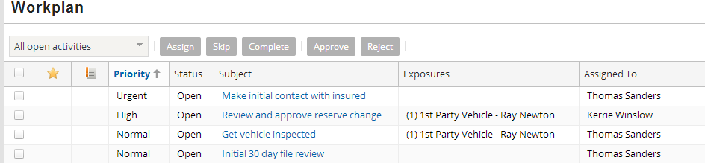

**Requirement 2: Approval for Year-Old Supplemental Payments**

A supplemental payment is a payment issued against a closed exposure. It is not uncommon for a supplemental payment to occur shortly after an exposure is closed. For example, an injury exposure might issue a payment of $7000, but the doctor determines that the initial treatment should be followed by a secondary procedure. In this case, a supplemental payment could be issued against the exposure for the second procedure.

At Acme Insurance, it is highly unusual for a supplemental payment to occur a year after the exposure is closed, though it does occur occasionally - particular for injuries whose long-term impact is not known when the claim is processed. Consequently, Acme wants to allow supplemental payments against exposures closed for a year or more, but these payments require approval by the group supervisor.

1. Create the script parameter named SupplementalPaymentMaxDays, whose initial value is 364. Deploy your script parameter.
   1. **NOTE:** Script parameters are configured differently in ClaimCenter 8.x and higher. If you are not familiar with creating/configuring script parameters in Guidewire ClaimCenter 8.x, follow these steps:
      1. In Studio, press CTRL+SHIFT+N to search for and edit the ScriptParameters.xml file.
      2. Add your new Script Parameter:

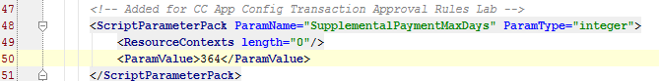  
<!-- Added for CC App Config Transaction Approval Rules Lab -->

<ScriptParameterPack ParamName="SupplementalPaymentMaxDays" ParamType="integer">

<ResourceContexts length="0"/>

<ParamValue>364</ParamValue>

* + 1. Restart ClaimCenter to use your new Script Parameter.
    2. Log on using su/gw. In the Administration screen you can view/reset the script parameter (Utilities > Script Parameters).

For more information on script parameters, consult the ClaimCenter Configuration Fundamentals training course.

1. Create the rule(s) needed to enforce these behaviors:

* Any payment transaction needs approval if the payment type is supplemental and the transaction date is more than SupplementalPaymentMaxDays after the date the exposure was closed.

1. The ClaimCenter implementation team has provided additional notes:

* To determine the transaction's date, use the TransactionDate field. This field has different meanings for different types of transactions. Consult the data dictionary for clarification on what it means for payments.
* The reason for the approval should be "Supplemental payment on exposure closed for over *X* days.", where *X* is the value of SupplementalPaymentMaxDays.

**Test Cases: Requirement 2**

When you have completed your configuration, run the following test case:

1. To simplify testing to the rules, log on to ClaimCenter as su. Reset the value of the Supplemental script parameter to -1. (This lets you test the rule without having to find an exposure which was closed over a year ago.)
2. Log on to ClaimCenter as Andy Applegate. Navigate to a claim.
3. Create an exposure, then create a reserve line on the exposure. Because supplemental payments are only permitted after a normal payment has been made, make a payment on the exposure and then close the exposure.
4. Make a payment on the claim using the reserve line you just created. Because the exposure is closed, the payment wizard forces you to make the payment supplemental.

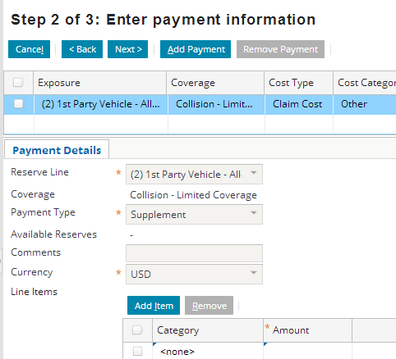

18. Verify that the payment requires approval, that the approval activity has been routed to the group supervisor, and that the issue for approval is correctly specified.

